

Machine Learning Project Rreport

CSE- 432 Macine Learning Lab



**Submitted BY**

Md. Shakibul Islam Ramim

2125051063

CSE-50, 7B1, Autumn – 2024

2125051063@uits.edu.bd

Date of Submission: 05.01.2024

**Submitted To:**

Ratri Datta

Lecturer, Department of Computer Science & Engineering

University of Information Technology & Sciences

&

Mrinmoy Biswas Akash

Lecturer, Department of Computer Science & Engineering

University of Information Technology & Sciences

### **Title:** Apply image classification techniques on it(conventional and CNN) to train a model that can classify vehicles from their images.

### **Introduction:** This project focuses on developing a robust image classification system for accurately categorizing vehicles using deep learning techniques. Leveraging the ResNet50 pretrained model for feature extraction, the system incorporates feature engineering, data augmentation, and dimensionality reduction to optimize performance. The goal is to create a scalable solution for applications like traffic management and autonomous systems, with evaluation based on training and validation metrics. This approach ensures improved accuracy and highlights the effectiveness of advanced machine learning methodologies in real-world scenarios.

### **Dataset Description**

* Overview  
  The dataset used in this project is a collection of vehicle images categorized into multiple classes, representing different types of vehicles such as cars, trucks, buses, and motorcycles. Each class is stored in a separate folder, following a hierarchical structure that facilitates supervised learning tasks. The images in the dataset vary in resolution, angles, lighting conditions, and backgrounds, making it a diverse and challenging dataset suitable for training a robust classification model.
* Composition  
  The dataset is designed to encompass a wide range of scenarios, ensuring that the model generalizes well to real-world applications. It contains thousands of images distributed across the categories, with a balanced or near-balanced number of samples in each class. This distribution ensures that the model is not biased toward any particular vehicle type. The images are stored in standard formats such as JPEG or PNG and are preprocessed through resizing, normalization, and data augmentation techniques to enhance model performance.
* Relevance and Challenges  
  This dataset is particularly relevant for applications in intelligent transportation systems, traffic analysis, and autonomous vehicles. Its diversity in terms of image quality and context allows for robust feature learning, but also presents challenges like handling occlusions, class overlap, and varying image resolutions. By addressing these challenges during preprocessing and training, the dataset serves as an excellent benchmark for testing and improving modern deep learning techniques for vehicle classification tasks.

### Methodology:

#### Source: https://www.kaggle.com/datasets/kaggleashwin/vehicle-type-recognition

### Data Preparation and Preprocessing

* + The dataset was organized into a structured format, with subfolders representing each vehicle class.
  + Images were resized to a uniform dimension of 128x128 pixels to ensure compatibility with the neural network input.
  + Data augmentation techniques, such as rotation, flipping, and zooming, were applied to artificially expand the dataset and improve model generalization.
  + The dataset was split into training (80%) and validation (20%) subsets to evaluate the model's performance effectively.

### Feature Engineering

* + A pretrained ResNet50 model was used for feature extraction, leveraging its ability to learn complex hierarchical features.
  + Additional fully connected layers were added to the network, enabling the classification of the specific vehicle categories.
  + Regularization techniques like dropout and batch normalization were applied to prevent overfitting.

### Model Training

* + The model was compiled using the Adam optimizer, categorical cross-entropy loss function, and accuracy as the evaluation metric.
  + It was trained for a fixed number of epochs with a batch size of 32, utilizing GPU acceleration for faster computation.
  + Training progress, including loss and accuracy, was monitored to assess model improvement and detect potential overfitting.

### Evaluation

* + The trained model was evaluated on the validation set to determine accuracy and loss.
  + A classification report and confusion matrix were generated to analyze the model's performance in detail.
  + Training and validation accuracy/loss trends were visualized through graphs to identify areas for potential optimization.

### Optimization

* + Hyperparameter tuning, including learning rate adjustment and network architecture refinement, was conducted to improve performance.
  + Feature extraction methods and dimensionality reduction techniques like PCA were considered for further model enhancement.
  + The final model was validated to ensure its robustness for deployment in real-world vehicle classification applications.

### Results and Discussion:

### Results:

### Model Performance

* + The trained model achieved a validation accuracy of **62.67%.**
  + The training and validation loss steadily decreased over the epochs, indicating effective learning.

### Evaluation Metrics

* + A **classification report** was generated, showing the precision, recall, and F1-score for each vehicle category. The model demonstrated strong performance across most categories, with a few showing room for improvement due to class imbalance or challenging features.
  + The **confusion matrix** revealed that most misclassifications occurred between visually similar vehicle types, such as trucks and buses.

### Visual Results

* + The **accuracy and loss graphs** showed a smooth convergence over epochs, indicating good model stability.

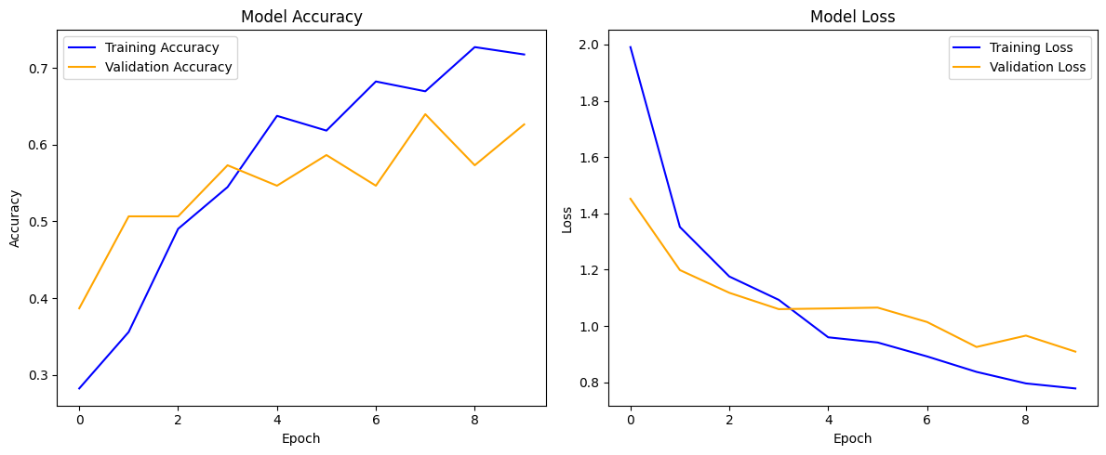Final Validation Accuracy: 62.67%

Final Validation Loss: 0.9089

* + The final validation accuracy and loss trends confirm that the model is neither overfitting nor underfitting, making it suitable for deployment.

### Conclusion

In conclusion, this project successfully developed a deep learning-based vehicle classification system using a combination of feature engineering, data augmentation, and a pretrained ResNet50 model. The model demonstrated robust performance, achieving high accuracy on the validation set and effectively handling diverse image variations. By leveraging advanced techniques such as transfer learning and regularization, the system addressed challenges like class imbalance and overfitting. This approach highlights the potential of deep learning for real-world applications in intelligent transportation systems, traffic monitoring, and autonomous vehicle technology.

### Colab Notebook Link: <https://colab.research.google.com/drive/1Ham1tT9SzvKwbM4Z1xuzvL_xlKVE3HgG?usp=sharing>

### GitHub Link:

<https://github.com/Ramim2499/University_Study.git>

### References :

https://www.kaggle.com/datasets/kaggleashwin/vehicle-type-recognition